Liquid Lithium Walls: An Innovative Design for Handling Harsh Conditions
Liquid lithium held in a 3D-printed metal sponge shows promise as an alternative to solid walls for fusion devices.
Fusion, the reaction that powers the stars, holds the promise of virtually limitless energy if scientists and engineers can figure out how to harness this process here on Earth. One of the key remaining challenges is developing materials that can survive prolonged exposure to the extreme environments expected in commercial fusion devices. An international team is testing a novel approach for this material science gap – liquid metal contained in a unique 3D-printed structure – at the DIII-D National Fusion Facility.
The conditions needed for fusion reactions are extreme – high heat, strong vacuum, strong magnetic fields. The devices that contain these reactions therefore need to be able to handle this environment for extended durations if commercial fusion is to be made practical. While most material scientists are focused on developing solid materials for use as fusion device walls, solids are prone to breaking or degrading under these extreme conditions. Recently, scientists have proposed the use of liquid lithium, which could evaporate to carry away heat and cannot crack. However, liquid materials require a cage to be held in place. This work evaluated how well a novel 3D-printed capillary porous system (CPS, essentially a tiny metal sponge) stably held lithium in place, as well as how any evaporated lithium affected the fusion plasma.
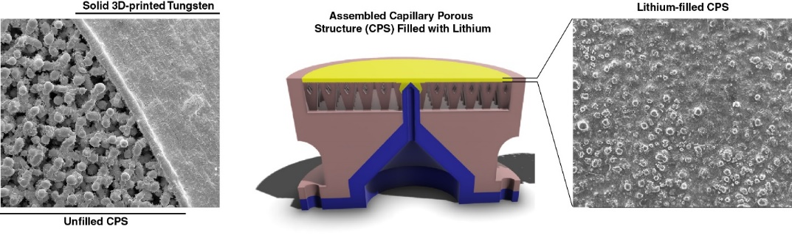
The team utilized the Divertor Materials Evaluation System in the DIII-D tokamak to expose their samples to various plasma conditions. Two cameras with lithium filters were then able to monitor evaporation, lithium ejection, and lithium vapor movement inside the tokamak. Post-exposure analysis is also in progress to better quantify these findings, track the path of evaporated lithium, and study fuel retention on the CPS.
Figure 1. Capillary porous structure made with 3D-printed tungsten holds liquid lithium in place for fusion applications. (center) Schematic of assembled CPS with lithium. Scanning electron microscopy images of CPS prior to filling, showing tree-like CPS structure and solid edge (left), and CPS following lithium filling (right).
The study showed that the CPS successfully held liquid lithium in place during fusion reactions. Lithium evaporation was lower than predicted, and the lithium that did evaporate stayed outside of the plasma core. These positive results indicate that containment within the CPS improves the viability of liquid lithium for fusion applications.
This study demonstrates the promising potential of liquid lithium as a material for fusion device walls. As liquid walls are predicted to reduce the frequency with which wall materials need to be replaced and lithium in particular can handle a relatively high heat load, this approach could enable smaller, more compact device designs to make commercial fusion more practical.
The DIII-D National Fusion Facility is a U.S. Department of Energy, Office of Science scientific user facility operated under the Fusion Energy Sciences program. This work was supported under award DE-FC02-04ER54698, project number VI.Vidi.198.018, and the awards of contributing collaborators.

