Higher Edge Density Protects Fusion Reactor Walls from Hot Plasma
New method could solve challenge facing future fusion power plants.
Magnetic fusion devices, called tokamaks, need to create extremely high core temperatures to maintain the fusion reaction, while keeping the intensely hot plasma away from the reactor walls. This is a challenge because the edge of the plasma is prone to instabilities that can produce bursts of energy through the confining magnetic fields. Known as “Edge Localized Modes” (ELMs), they can be powerful enough to damage the tokamak vessel.
A narrow region of the plasma edge, which scientists refer to as the pedestal, is an area of steep temperature and density gradients. The pedestal helps to maintain high core temperature and density, but also makes the plasma susceptible to instabilities. Past experiments have shown that conditions in the pedestal can have important effects on the plasma core, including efforts to control ELMs.
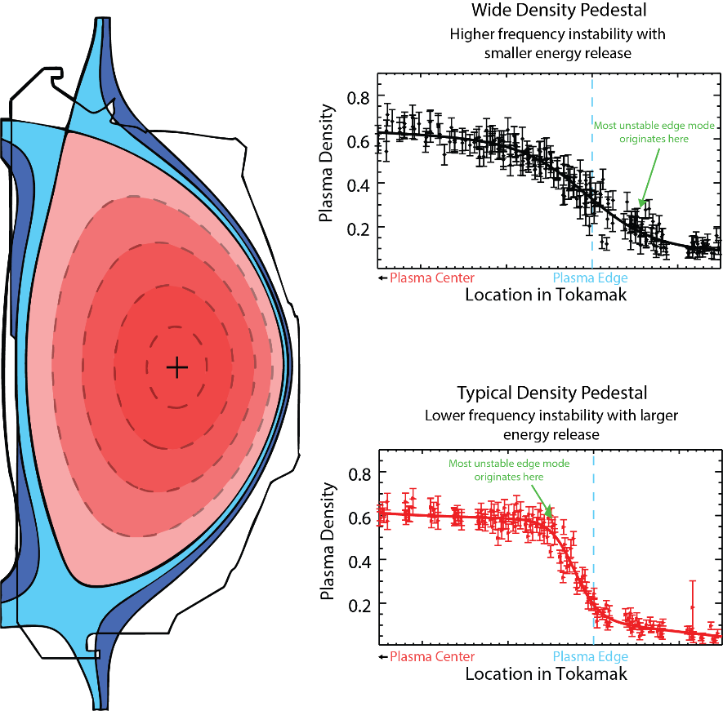
A team at the DIII-D National Fusion Facility in San Diego recently explored ways to reduce the severity of ELMs while maintaining high core temperatures by increasing the density of the outermost region, known as the scrape-off layer (SOL), of the plasma. The SOL is a region of the tokamak where the magnetic field lines intersect with the reactor walls. Increasing the fueling rate from both the inner and outer walls of the tokamak increased the SOL density, broadening the density pedestal. This broader pedestal led to more rapid ELMs that released much smaller amounts of energy, thus reducing the risk of damage to the reactor walls.
Figure 1: A wide-density pedestal maintains a hot plasma core while protecting fusion device walls. (left) A cross-section of the DIII-D tokamak shows confined plasma in red and unconfined particles in blue, with the plasma edge defined by the black loop separating the red and blue zones. (right) Plots showing plasma density across the tokamak cross-section, from the plasma core to the device wall. The plasma edge is indicated by the blue dashed line.

In addition to the fueling rate, the shape of the plasma was important for accessing this high-frequency ELM regime. The plasma cross-section needed to be squarer than the traditional “D” shape.
A related discovery concerns a component in the tokamak called a divertor. The divertor acts to dissipate excess heat and exhaust particles from the edge of the plasma, which means it can be exposed to extreme temperatures and particle flow. To protect the divertor, scientists try to create a region of low temperature and high light emission between the divertor and the plasma edge. They refer to this approach as a “detached divertor” because the plasma is kept from contacting the walls. However, this can also negatively affect core temperatures.
In these experiments, the researchers created a detached divertor by adding nitrogen in the divertor region during fueling. They discovered that the wider density pedestal also helped to maintain a high core temperature during divertor detachment.
The DIII-D National Fusion Facility is a U.S. Department of Energy, Office of Science scientific user facility operated under the Fusion Energy Sciences program. This work was supported under award DE-FC02-04ER54698, DE-AC52-07NA27344, and the awards of contributing collaborators.

